Sigmund Kasatkin Photography
Album Prices 2020

Graphistudio Wedding Book  Lay-flat story book available in three  sizes.  A large choice of covers including  metal, leather, leatherette, silk, and  acrylic. | 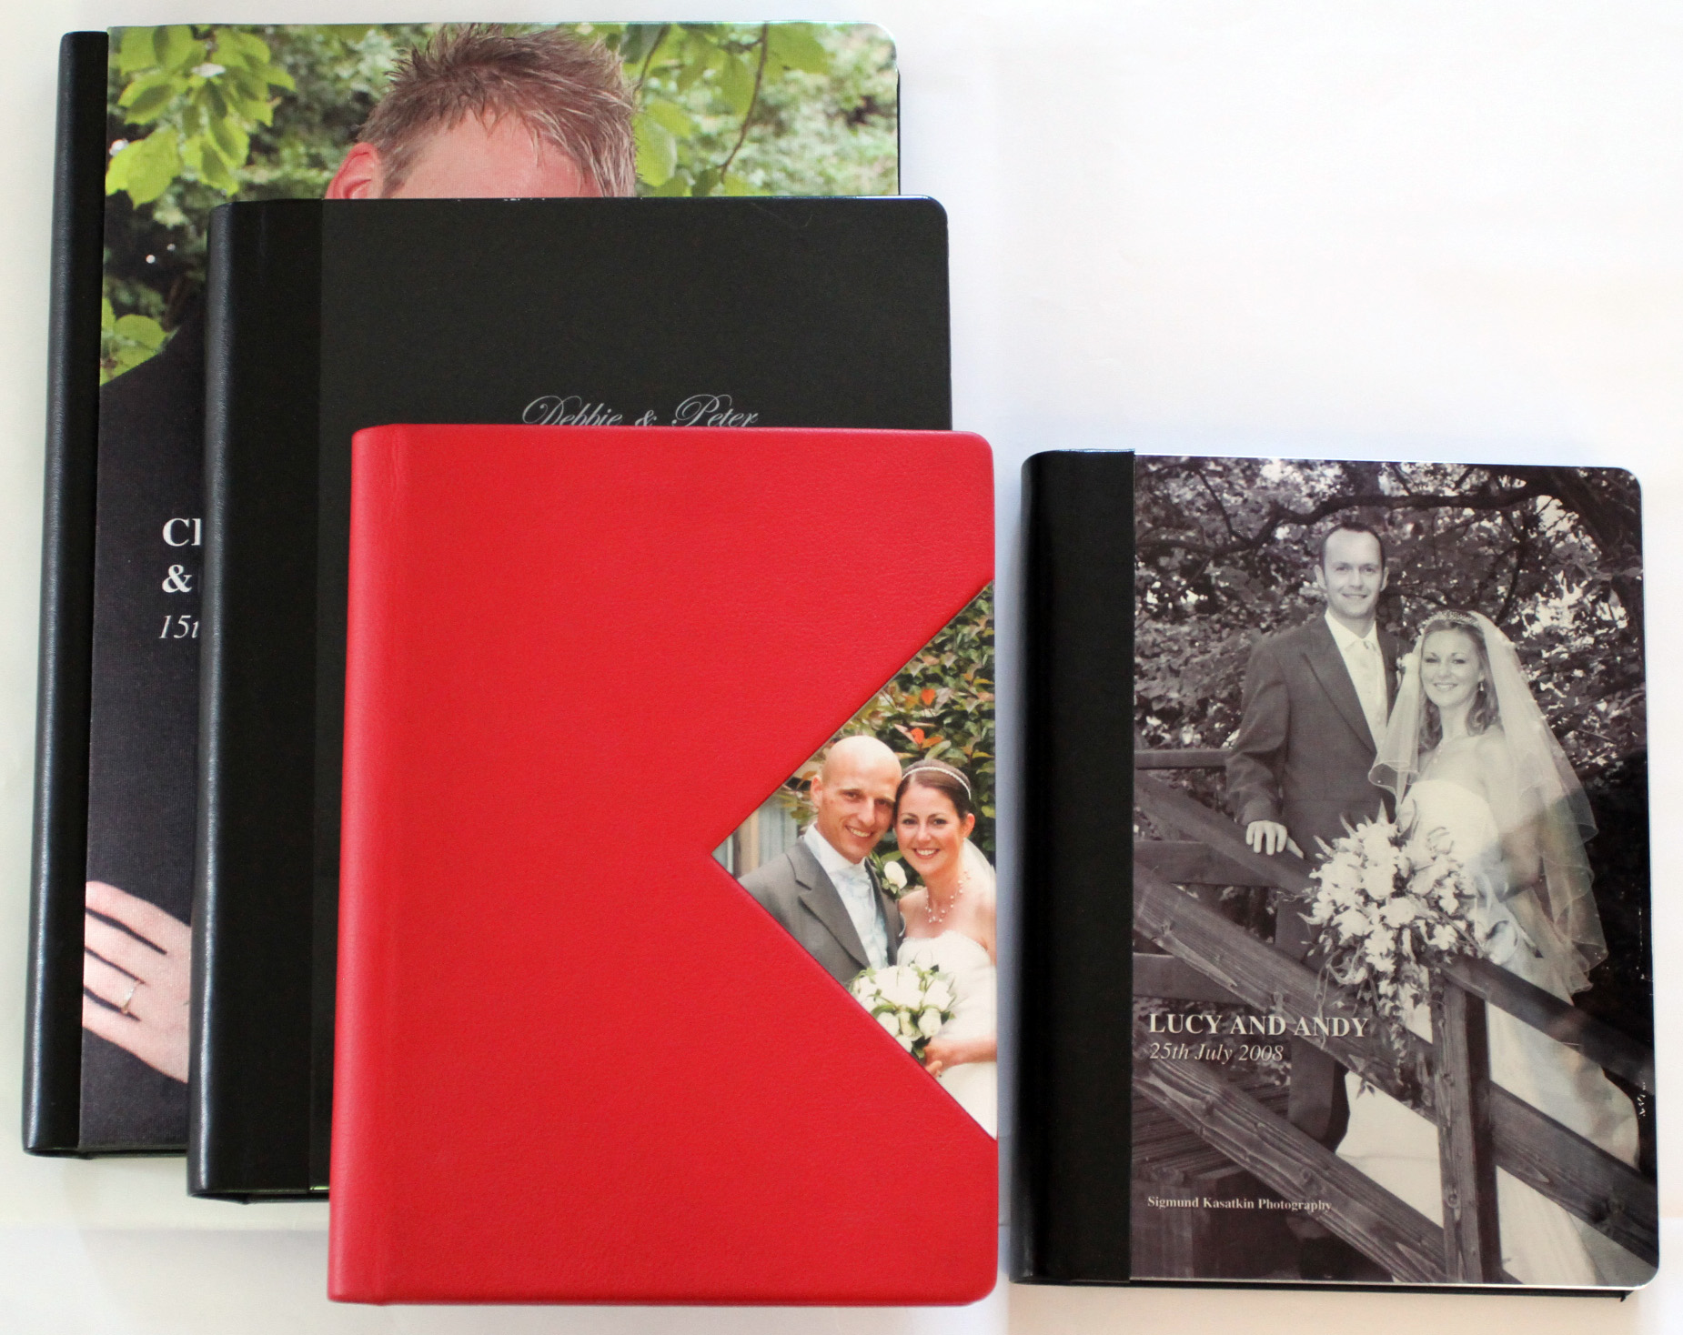 | 30 pages  extra pages | 12”x8” 14x10 16x12  (30x20 35x25 40x30)  £350 £450 £550  £5 £5 £5
Graphistudio Wedding Book  (Glossy Hardback Cover)  Lay-flat story book printed on lustre photographic paper and with a hard backed printed cover. | 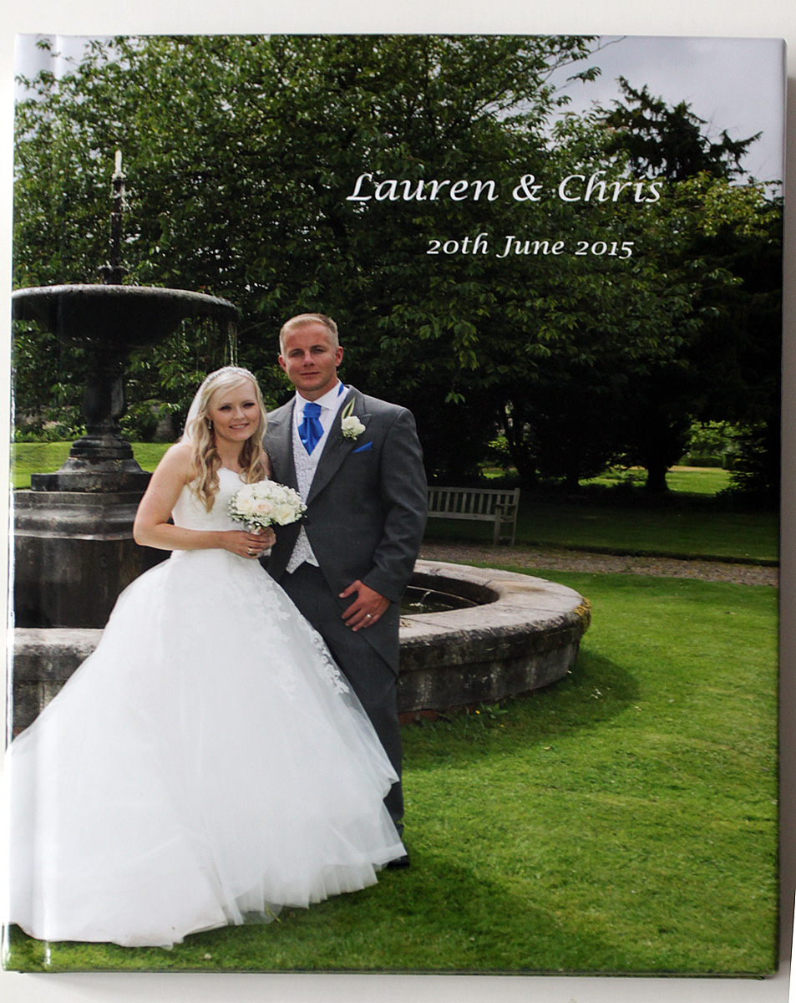 | 30 pages  extra pages | 12”x8”  (30x20)  £250  £5
Graphistudio Wedding Book  Parent Copies  Exact copy of the main book with  a hard backed printed cover. | 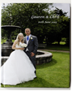 | Same pages  as main  album | 12”x8” 8”x6”  (30x20) (20x15)  (1 copy) (2 copies)  £150 £150  5”x4”  (13x10)  (4 copies)  £150

www.WeddingShots.co.uk
sig@weddingshots.co.uk 07790 227720

Amalfi Storybook  This unique album is ideal for those  special images on the bride and  groom.  Soft sequoia leather covers this 28  page hand stitched Amalfi paper storybook.  The pages are 20 x 30cm vertical  orientation with one 15 x 20cm  image per page. | 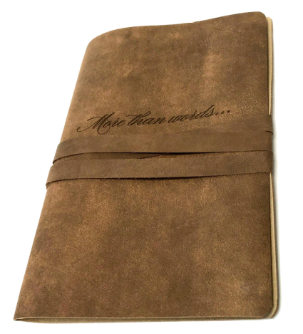  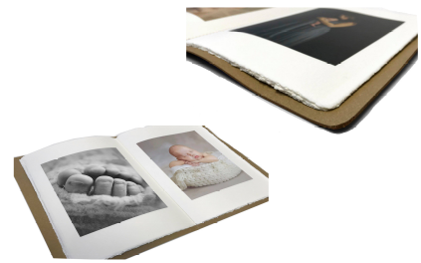 | 28 pages | 30cm x 20cm  £250
Wedding Magazine  (Soft Cover)  A glossy magazine presentation of  your chosen images  Ideal for parents or bridesmaids.  27cm x 20.5cm  (just smaller than A4) | 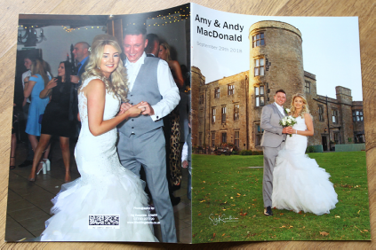  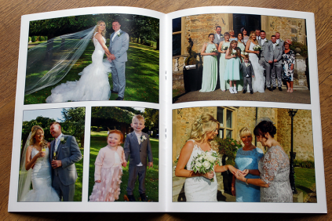 | 26 pages  (60 photos)  Extra copies  Extra 4  pages  (8 photos) | £150 for 4 copies  £25 each  £6

www.WeddingShots.co.uk
sig@weddingshots.co.uk 07790 227720

Graphistudio YoungBook  Lay-flat book with thick pages, presented in a solid box. Available in three sizes and in portrait or landscape format.  The book, box and ribbon are all available  in customised materials and colours. | 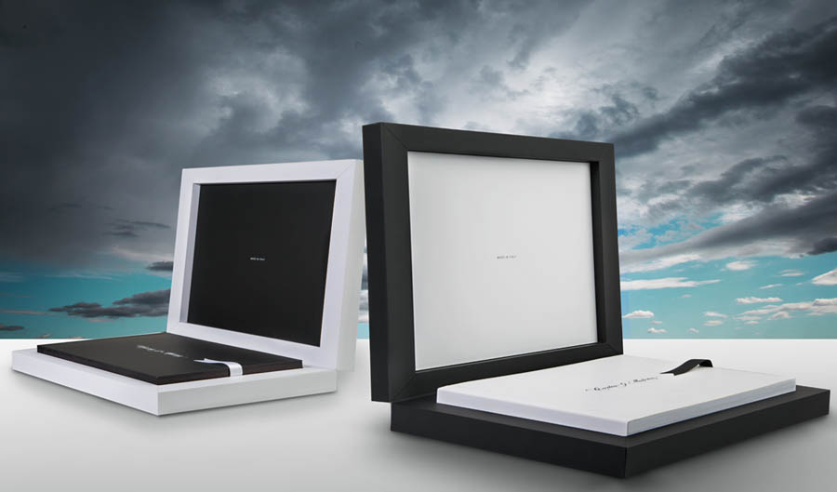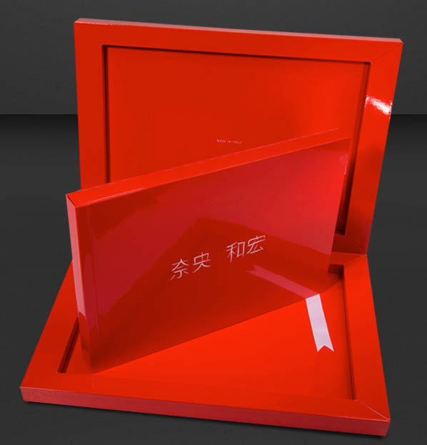 | 30 pages  extra pages | 12”x8” 14x10 16x12  (30x20 35x25 40x30)  £350 £450 £550  £5 £5 £5  +10% for metallic paper
Graphistudio GO Book  A lay-flat book printed on photographic  paper with thin pages, with a photo cover  and presented in a box with a transparent lid.  The book, box and ribbon are all available  in customised colours. | 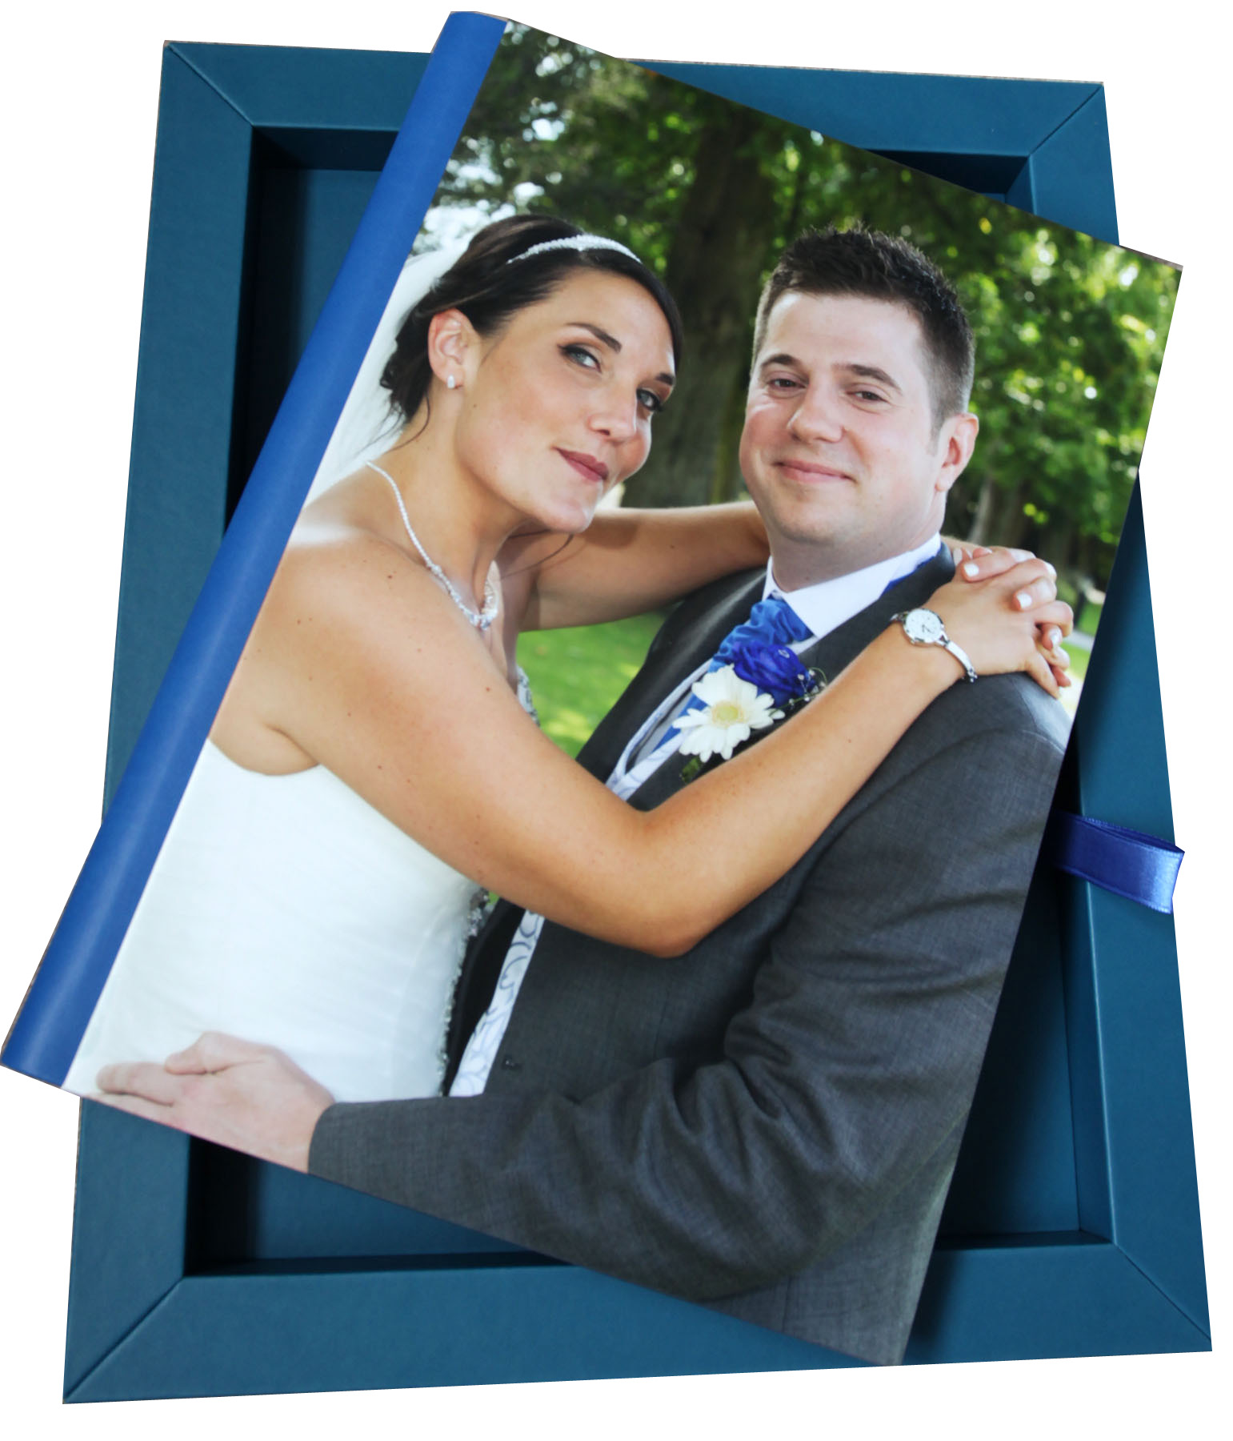 | 20 pages  extra pages | 12”x8” 14x10  (30x20) (35x25)  £250 £350  £5 £5
Graphistudio Baby Book  A lay-flat book printed on lustre  photographic paper with thick pages,  presented in a box.  The book, box and ribbon are all available  in customised materials and colours. | 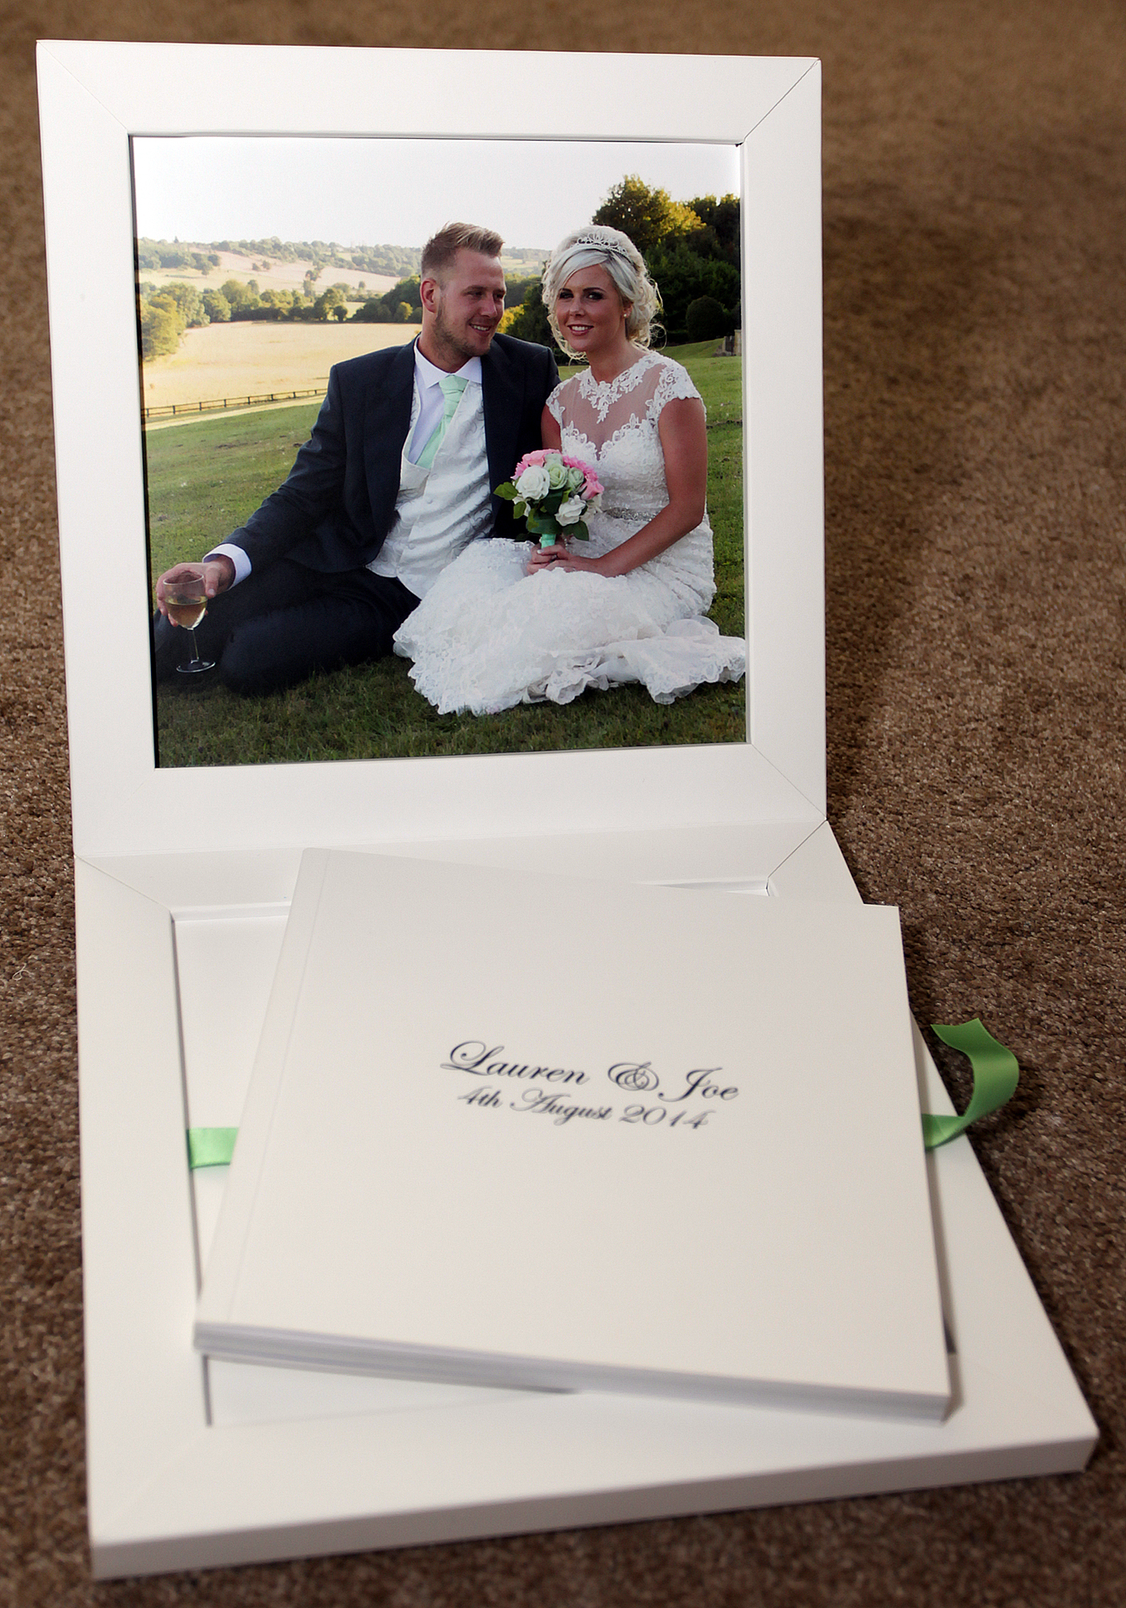 | 20 pages  extra pages | 8”x8 “ 12”x8”  (20x20) (30x20)  £160 £250  £5 £5  +20% for metallic paper

www.WeddingShots.co.uk
sig@weddingshots.co.uk 07790 227720

